Labdoo.org “autodeploy” and “auto install content” scripts
These 2 bash scripts are designed to automate the restoration of the images and the content of the lubuntu 18.04 based labdoo systems, allowing to perform a complete end-to-end sanitazion of the laptop in an unattended way.
Autodeploy_18.sh :
shredding of the harddrive (optional)
restoration of the selected image
configuration of a new hostid
deployment of all the additionall contents of the languages you choose automatically
install_content_labdoo.sh :
restore all contents that fit on the HD (based upon a configurable “priority list” of the contents [web and xowa wikis] downloaded in the HD) that fit in the HD (leaving an acceptable [and configurable] margin of free space)
Expected structure of the files on the USB Hard Drive
The default provided scripts are configured considering the following tree on the used USB Hard drive, which is the “Stadard labdoo USB HD”.

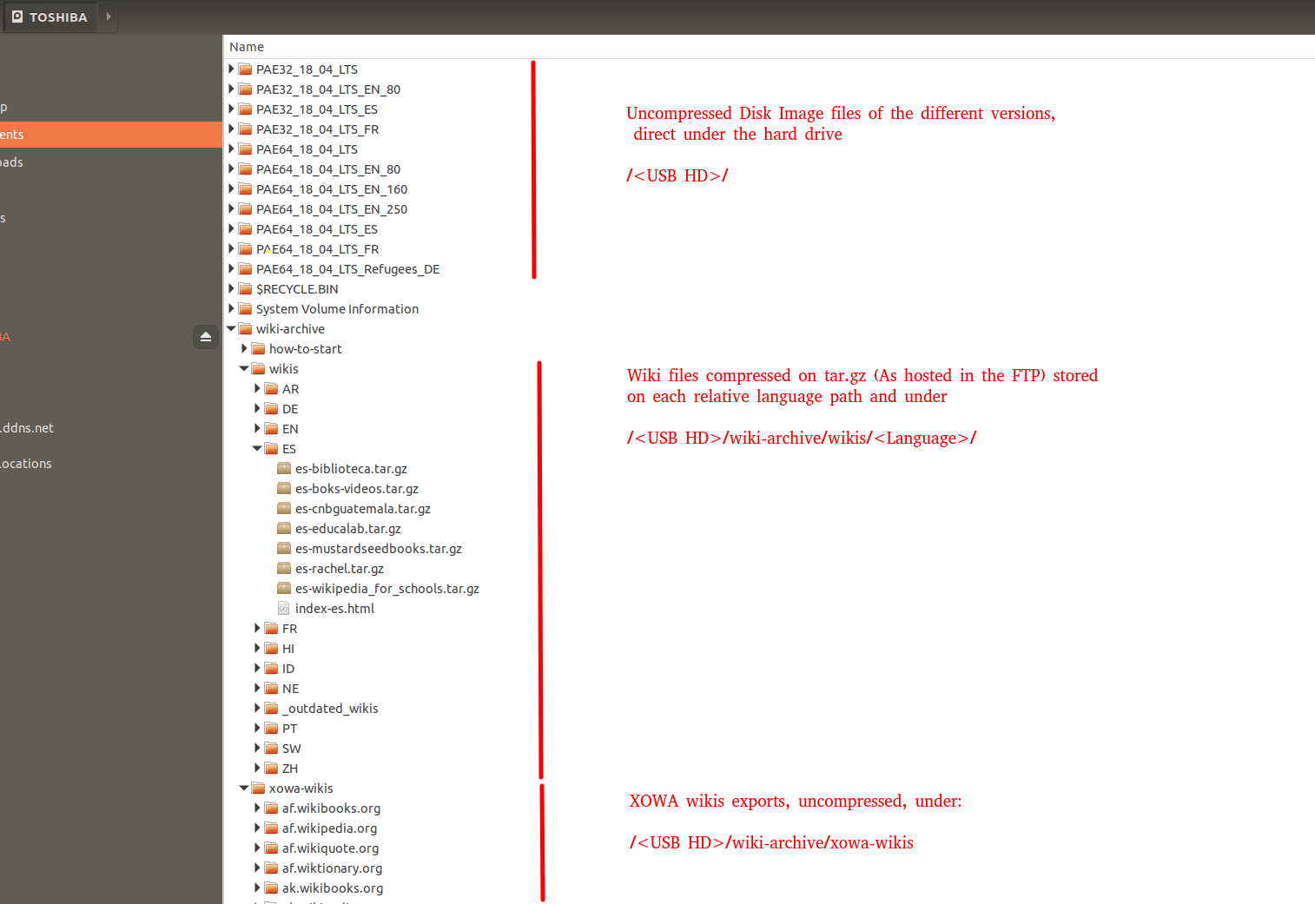

autodeploy_18.sh

Configuration Parameters

You just can configure the following information about the image files you are working with, but by default the configuration matches the images offered in the FTP server [and the ones that are installed in the “Stadard labdoo USB HD”:
bits of the image [32,64]
language of the image [EN,ES,DE,FR]
size: maximum size of the HD in wich this image can be installed (will be used by the script to decide what to install)
name of the image
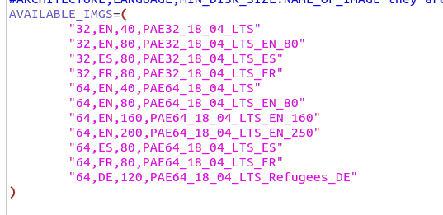
Running the script

Once you have started with Labtix, you can execute it by clicking the Autodeploy icon in the desktop

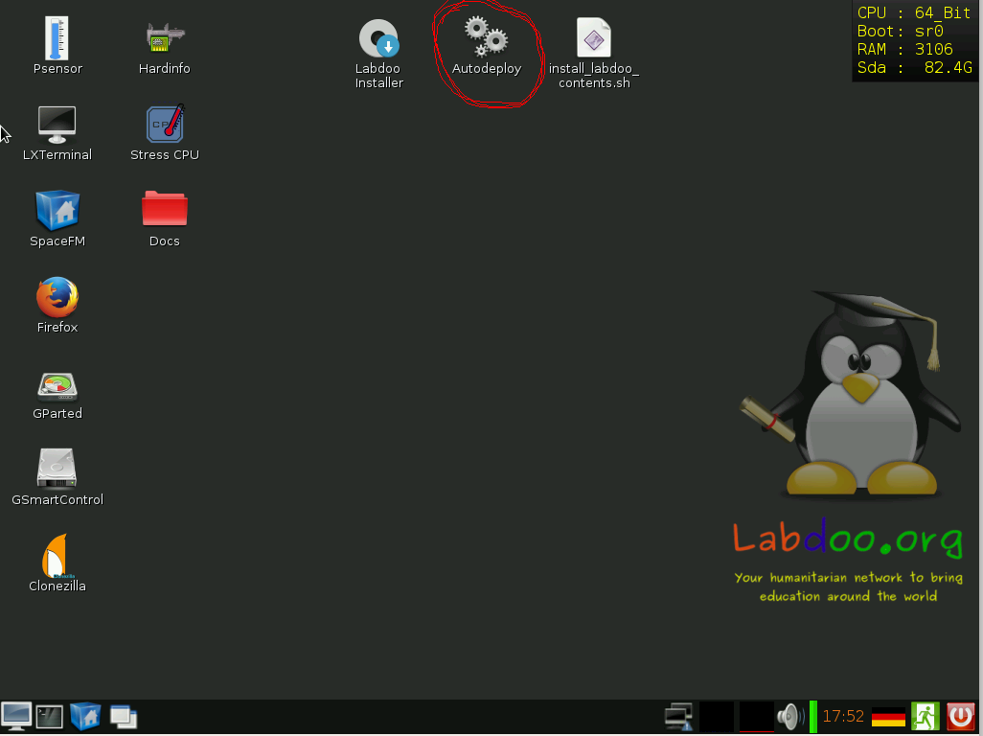
Run the script and answer carefully the questions (specially the first ones related to the units to delete and to restore from)
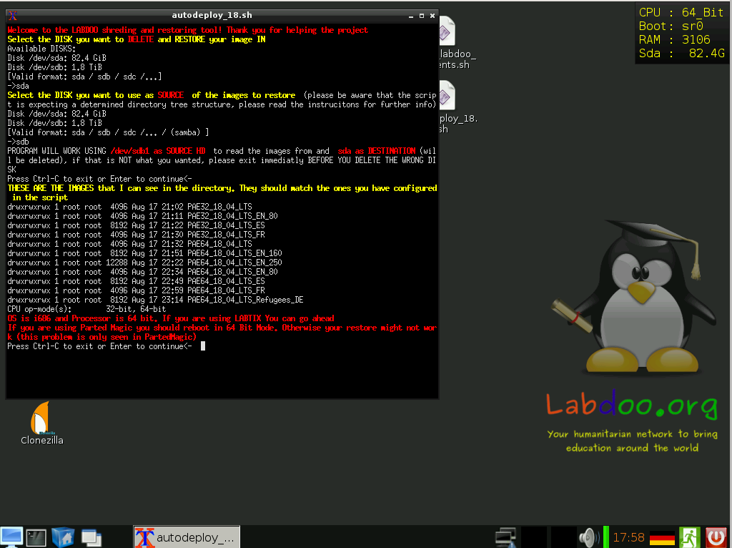

You will be as well asked about:
- Language to restore
- Exact image to restore (system offers you, from those configured, the ones that suit the system architecture, the HD size and the selected language
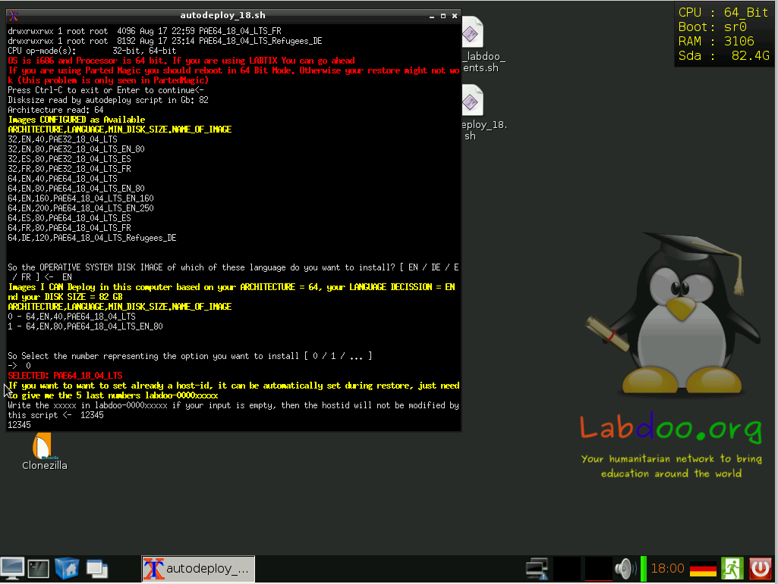
- New hostid to be set (if you have one, you can have it automatically set)

- possibility to skip the shredding (ONLY Select if the laptop has already been erased previously or you are using a new HD, remember that deletion of data in donated laptops is mandatory)
- possibility to install additional contents (very recommendable, to include as much educational content as possible!!) [it does it by automatically calling the install_content_labdoo.sh script]
currently supported languages:
[ES / EN / SW / AR / HI / DE / FR / NE / ID / PT / ZH / RU / RO / IT / FA]
- what to do after the process is finished (I personally find it usefull sending the laptop to sleep, since it allows you to save power once finished, but also to wake it up afterwards and see how the process finished [as opposed of just having it shutted down])

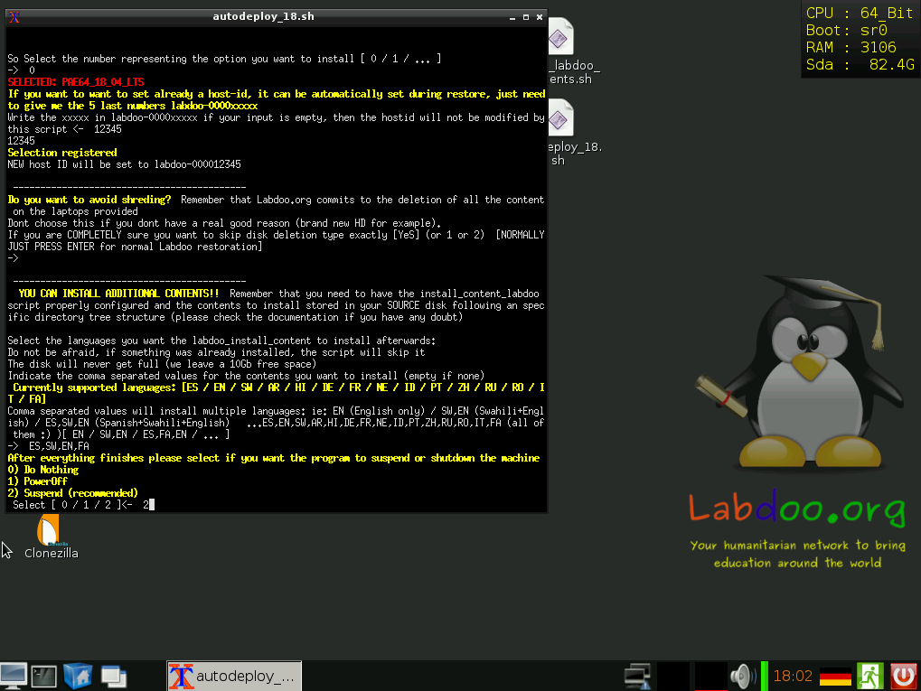

Fulfill this info and start deploying!!! :)

install_content_labdoo.sh
This script is totally automated and does not require any input from the user, if you like the configuration (or after you have setted to your taste) you just have to invoke it.
It will deploy the contents, adapt the index.html file so that only the installed content is showd in firefox and run once again the “set permissions correctly” script to avoid permission problems.
It will help you make sure that the students get all the possible content, after all, it was not so easy to bring the laptop to them
Configuration Parameters

You can reconfigure the following information about the content files you want to deploy but by default the configuration matches the images offered in the FTP server [and the ones that are installed in the “Stadard labdoo USB HD”] so do not change it if you dont really need:
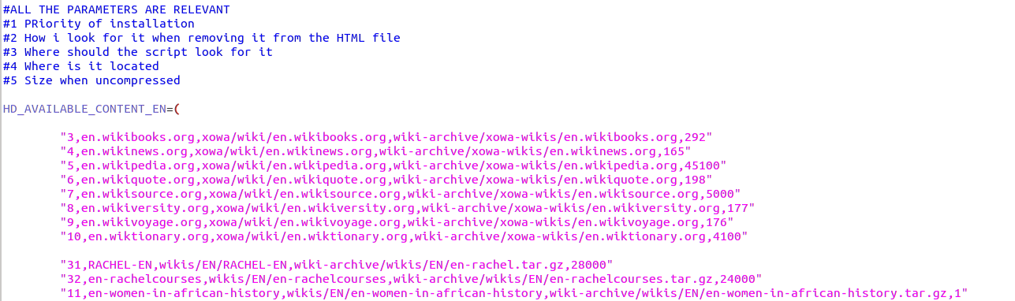
You might change at the priority order on which you want to have things deployed (until HD is full), I have given priority to the wikis and the Rachel contents as well as the “women in Africa history”, but you might change it at will (do not assign same number to different contents, otherwise one of then will be skipped)
Dont worry about the size, the script will try to install everything (if only 10 Gb are avialiable, and the first thing you have selected takes 20G, it will not break, will just skip it, and see if the next content in your priority list fits)
The installation will leave allways the space configured as MB_TO_BE_LEFT as free, you might change this value as well

Using the script

This is an easy one, plug the USB HD, invoke the script and go to sanitize in between a new laptop :)
Current supported languages:
[ES / EN / SW / AR / HI / DE / FR / NE / ID / PT / ZH / RU / RO / IT / FA]

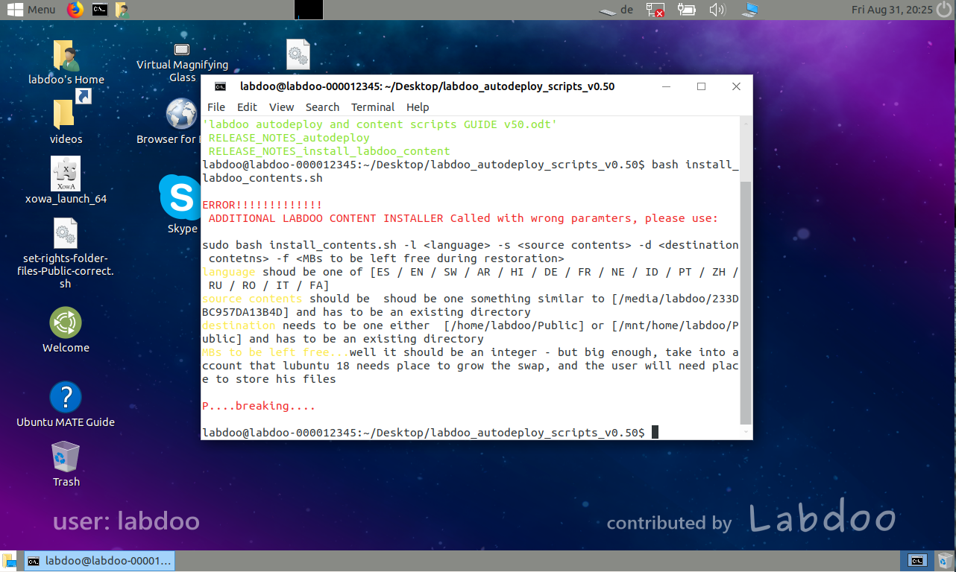

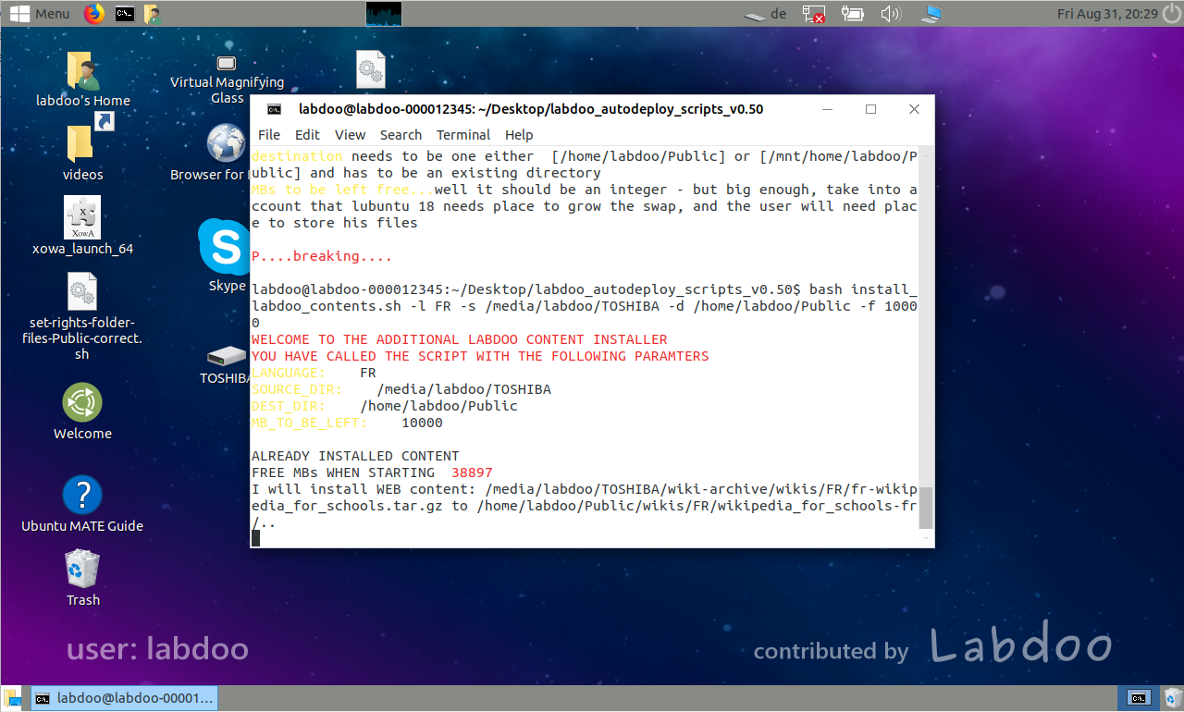

DISCLAIMER: we are under constant development
latest updated copy of this document was for scripts version v0.52

contents of the package:
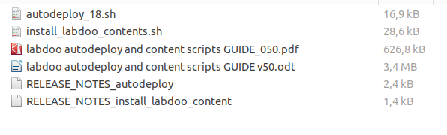
Please visit labdoo.org to keep up with the new developments and submit your ideas in the forums (and report any bug you may find), submit any doubt you might have to labdoo support wall
https://www.labdoo.org/content/labdoo-global-support-lgs/activities
Maintained versions of these scripts are to be found under:
https://github.com/jprisab/labdoo_labtix
Please feel free to modify any script to adapt to your requirements and preferences

